# 

# PROJECT DOCUMENTATION



# DIABETES PREDICTION

# USING

# MACHINE LEARNING

### TEAM:

### 

### B.V.V.MAHESHA CHANDRA

### K.POORNA AVINASH

### M.MANOJ BHASKAR

**V.GOWRI SHANKAR**

### 

# INTRODUCTION

Millions of people worldwide suffer with diabetes mellitus, a chronic metabolic illness. Elevated blood sugar levels brought on by insulin resistance or insufficient insulin production are its defining characteristics. Effective diabetes management and the avoidance of complications depend on early detection and precise diabetes prediction. Machine learning techniques have become highly effective tools for predicting outcomes and analyzing large amounts of medical data in recent years. This project uses a comprehensive approach that combines multiple data sources and cutting-edge algorithms to develop a robust and trustworthy machine learning model for diabetes prediction.

Our goal in machine learning is to develop a model that, using diagnostic measurements, can reliably predict whether a patient has diabetes. Our dataset consists of one target variable (Outcome) and multiple medical predictor variables. These predictors include things like age, sex, body mass index (BMI), smoking, high cholesterol, blood pressure, stroke, and heavy alcohol consumption.

A potent tool for predicting a number of diseases, including diabetes, is machine learning (ML). Massive data sets can be analyzed by ML algorithms to find patterns and relationships that humans might not notice right away. Predictive models that can identify people at risk of developing diabetes can then be developed using these patterns.

In conclusion, the goal of this project is to create a trustworthy and accurate diabetes prediction model by utilizing the combined strengths of extensive data integration and machine learning. Through the integration of various data sources and the application of sophisticated algorithms, this project aims to significantly advance the early detection and prevention of diabetes, ultimately enhancing the quality of life for those afflicted with this chronic illness.

# 

# LITERATURE SURVEY

A literature review for "Diabetes Prediction Using Machine Learning" entails reading through previous investigations and studies to comprehend the approaches, algorithms, and conclusions. This is a brief overview of the literature that highlights important facets of this field's research:

1. Overview of Diabetes Prediction: Because machine learning has the potential to aid in early detection and prevention, diabetes prediction has attracted a lot of attention recently.Traditional risk factors, such as age, BMI, and family history, were frequently the focus of early research.

2. Feature Selection and Extraction: To find the most pertinent diabetes predictors, numerous studies stress the significance of feature selection and extraction.Age, BMI, blood pressure, cholesterol, and lifestyle factors are common characteristics.

3. Machine Learning Algorithms: For the purpose of predicting diabetes, researchers have looked into a number of machine learning algorithms, such as ensemble techniques like random forests, logistic regression, decision trees, and support vector machines.The dataset's properties and the intended balance between interpretability and accuracy are major factors in the selection of algorithms.

4. Integration of Clinical and Genetic Data: In order to improve prediction accuracy, some studies have combined clinical and genetic data.In recent studies, genetic markers and polymorphisms linked to the risk of diabetes have been examined.

5. Cross-Dataset Validation: A crucial component of solid diabetes prediction research is the validation of models on a variety of datasets.Research frequently touch on the need for generalized models and the difficulties presented by heterogeneous datasets.

6. Interpretability and Explainability: These qualities are becoming more and more important as machine learning models get more complicated. The goal of research is to create models that can not only make predictions but also shed light on the variables that affect them.

7. Real-world Implementations: A few studies investigate whether diabetes prediction models can be used in actual healthcare settings.Integration with clinical workflows and electronic health records is a topic of interest.

8. Challenges and Future Directions: Data imbalances, interpretability problems, and the requirement for ongoing model adaptation are just a few of the challenges that have been highlighted in the literature.In the future, we'll investigate personalized medicine strategies and deal with ethical issues.

9. Comparative Analyses: The literature frequently presents comparisons between various machine learning models and conventional risk assessment instruments. Research frequently compares machine learning models' performance to well-established clinical risk assessment techniques.

In conclusion, the body of research on machine learning-based diabetes prediction illustrates a dynamic and developing field that draws from a variety of features, algorithms, and data sources. The potential of machine learning to advance diabetes prediction and preventive healthcare is highlighted by the ongoing efforts to improve model accuracy, interpretability, and real-world applicability.

# 

# IDEATION & PROPOSED SOLUTION

**CANVAS EMPATHY MAP :**

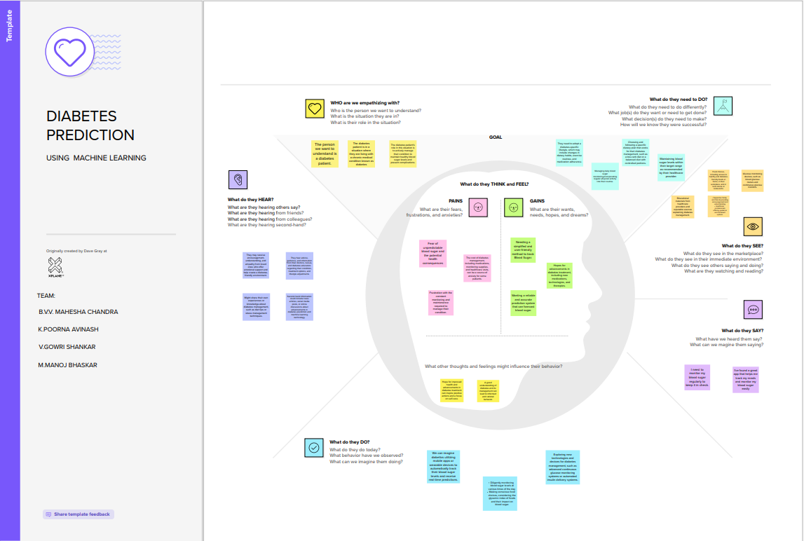

**IDEATION AND BRAINSTROMING:**

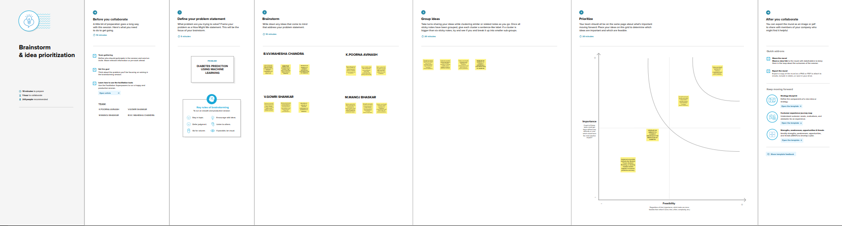

# 

# REQUIREMENT ANALYSIS

Functional specifications:

Data Collection: Age, gender, family history, BMI, blood pressure, and blood sugar levels are just a few of the pertinent patient data that the system should be able to gather and process.

Data Preprocessing: In order to handle missing values, outliers, and data normalization, the system needs to preprocess the data.The data ought to be able to be cleaned and formatted for input into machine learning models.

Machine Learning Model: A machine learning model that forecasts a person's risk of acquiring diabetes should be implemented by the system.For the model to produce precise forecasts, it must be able to learn from past data.

Feature Selection: In order to determine which attributes are most pertinent for diabetes prediction, the system should use feature selection techniques.

Both automated techniques, such as feature importance, and manual feature selection should be supported.

Training and Testing: Using a labeled dataset, the system should train the machine learning model.It should also allow accuracy testing of the model with an independent test dataset.

Prediction: The system ought to have the capacity to receive patient data and produce an estimate of the probability that diabetes will manifest.

User Interface: In order to allow users to interact with and enter patient data, the system should have an intuitive user interface.It ought to show forecast outcomes and graphics to support decision-making.

Data Storage: In accordance with data privacy laws, the system must securely store patient data.

Security: To safeguard patient data and stop unwanted access, the system needs to have security measures in place.

Security: The system should implement security measures to protect patient data and prevent unauthorized access.

Non-Operative Conditions

Accuracy: The system ought to predict diabetes with a high degree of accuracy while reducing false positives and false negatives.

Performance: To guarantee prompt decision-making, the system must deliver predictions in a reasonable amount of time.

Scalability: The system must be able to accommodate an increasing amount of patient data and change to meet evolving needs.

Reliability: The system must be accessible and functional with the least amount of

downtime.

Privacy and Compliance: To guarantee patient data security and privacy, the system must abide by data protection laws like GDPR and HIPAA.

Explainability: To gain the trust of users and medical professionals, the machine learning model must be comprehensible and able to explain its predictions.

User-Friendly Interface: To accommodate users with different levels of technical expertise, the user interface should be simple to use and intuitive.

Maintenance: As new data becomes available, the system should be able to handle updates and enhancements to the machine learning model.

Integration: For data interchange and interoperability, the system must be able to integrate with electronic health records (EHRs) or other healthcare systems.

Ethical Considerations: The system should abide by the moral standards governing the application of machine learning in healthcare, which include treating patients fairly and mitigating bias.

Documentation: To promote comprehension and support, the project should contain thorough documentation for users, administrators, and developers.

# 

# PROJECT DESIGN

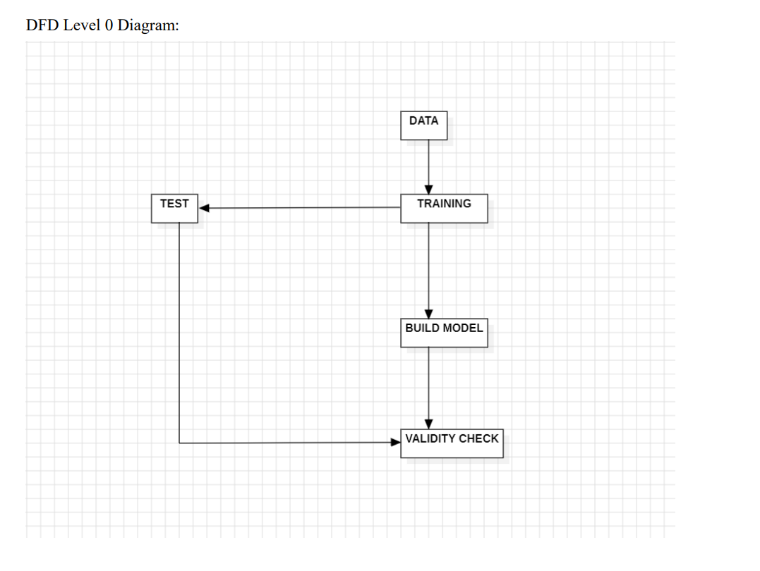

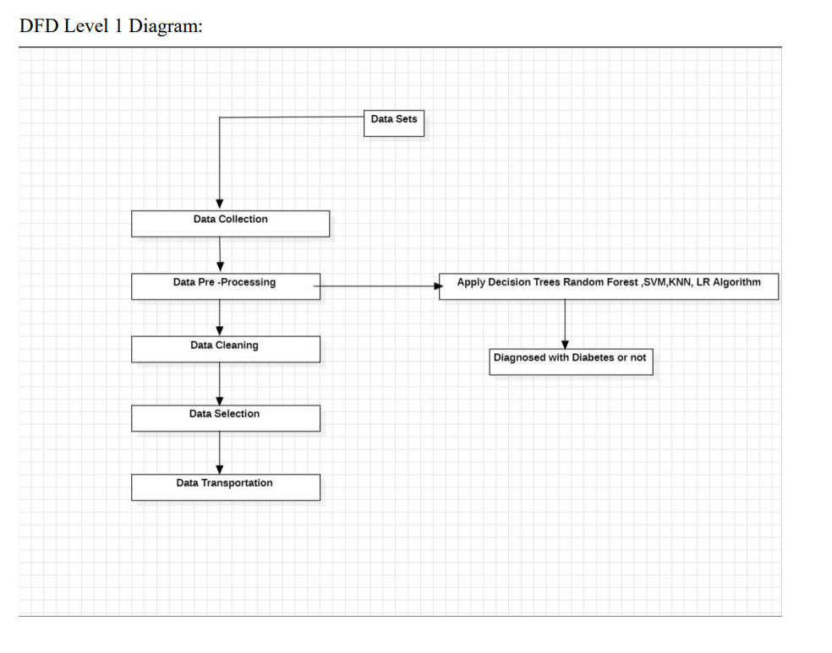

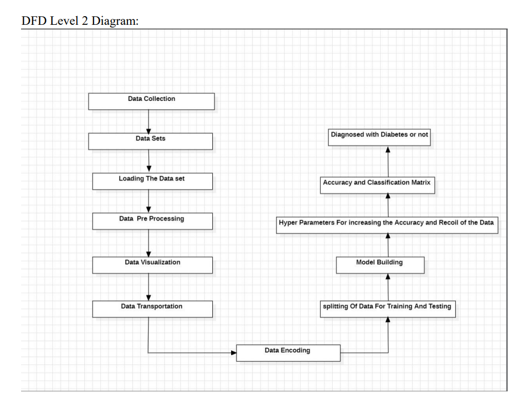

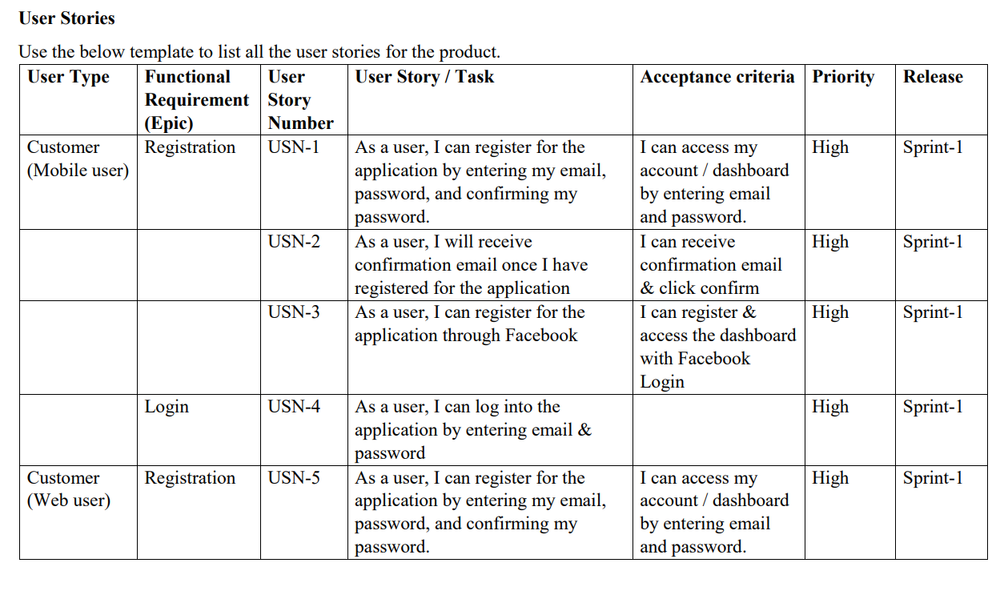

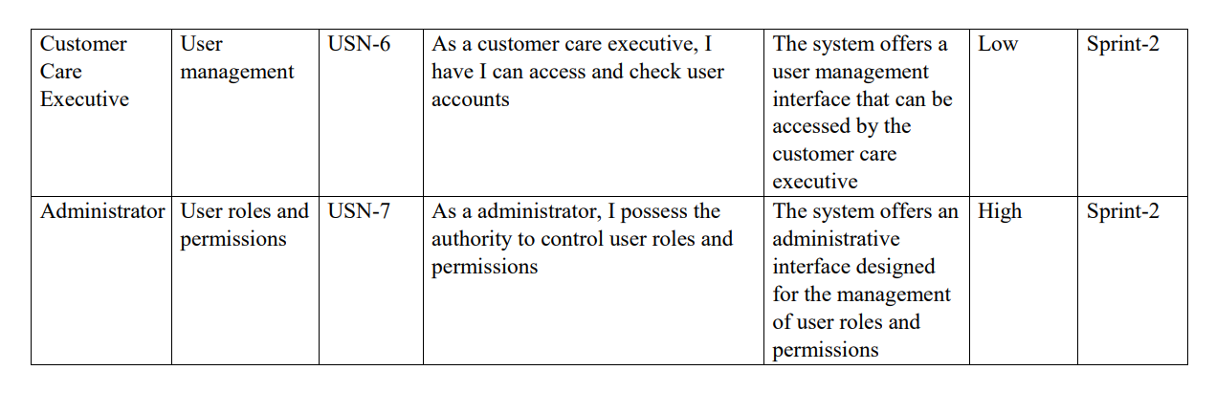

# 

# SOLUTION ARCHITECTURE:

The goal of the multi-step approach for diabetes prediction using ML models is to create a scalable and reliable system that can predict a person's risk of acquiring diabetes by analyzing a variety of health data. The following is a detailed overview of the architecture:

1.Data Collection: A variety of sources, including wearable technology, electronic health records, and patient input, are employed to gather pertinent health data for diabetes prediction. BMI, blood pressure, glucose levels, family history, and other pertinent factors are among the data gathered.

2. Preprocessing Data: The gathered health data is subjected to preprocessing procedures as cleaning, normalization, and feature extraction in order to guarantee data quality and consistency.

3.Feature Selection: Statistical methods or domain expertise are used to choose the most pertinent features for diabetes prediction. By taking this step, the noise is reduced and the most important variables are highlighted.

4.Model Training: Historical diabetes data is used to train machine learning models, such as logistic regression, decision trees, random forests, or support vector machines, for the prediction of diabetes. In order for the models to learn patterns and correlations, the pre?processed data must be fed to them during the training phase.

5.Model Evaluation: Evaluation metrics like accuracy, precision, recall, and F1 score are frequently used to evaluate the performance of the trained models and choose the most accurate model or models) for predictions.

6. Predictive Analysis: Based on fresh input data, the most accurate machine learning models are chosen and put to use to forecast a person's risk of acquiring diabetes. The models produce predictions with corresponding probability scores by using the features that they have chosen and the patterns they have learned.

7.Deployment and Integration: The prediction system can be made available to stakeholders, individuals, and healthcare professionals as a stand-alone application or integrated into already-existing healthcare systems.

8. Continuous Improvement: The ML models can be retrained to adjust to changing patterns and increase prediction accuracy as new data becomes available, ensuring the prediction system's performance is continuously monitored and assessed.

Delivering a precise and trustworthy diabetes prediction system that permits early disease detection and prevention is the main goal of the entire process.

The architecture guarantees scalability, flexibility, and adaptability to integrate new health parameters and advances in machine learning techniques for continuous system improvement

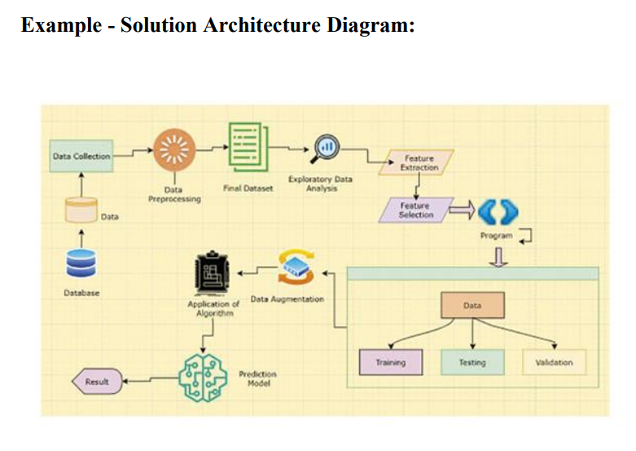

# 

# PROJECT PLANNING & SCHEDULING

**Technical Architecture**

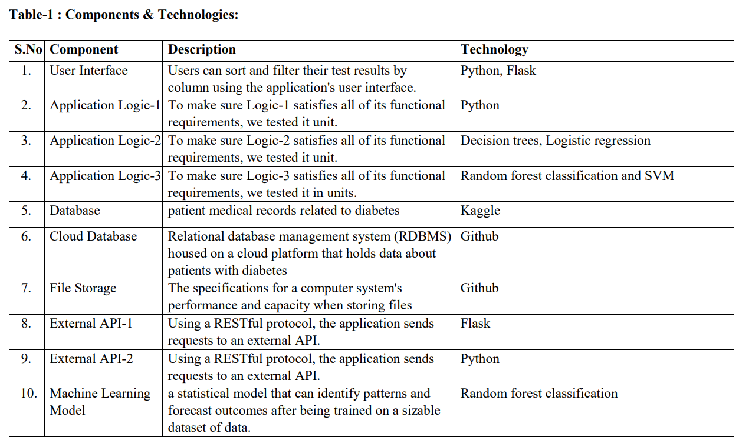

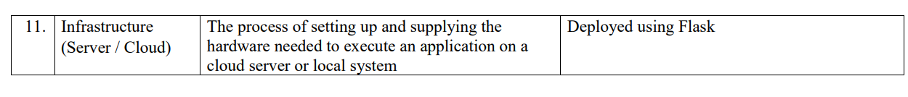

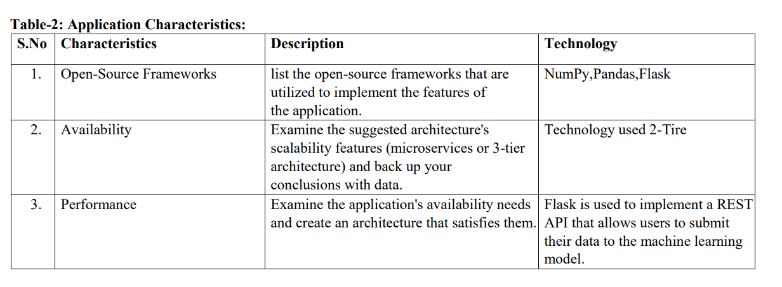

**Sprint Planning & Delivery Schedule:**

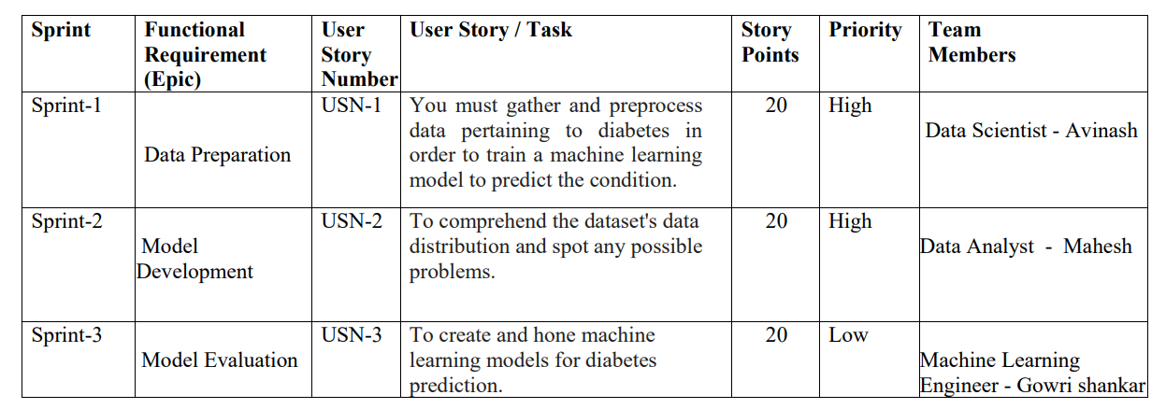

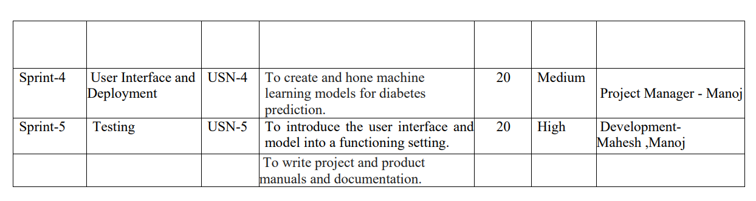

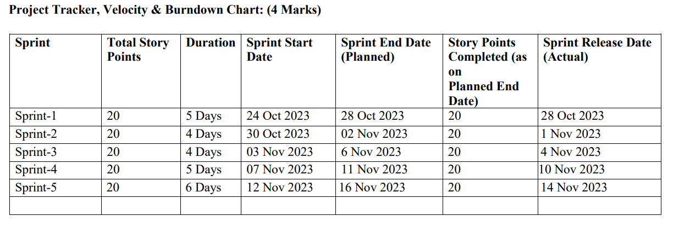

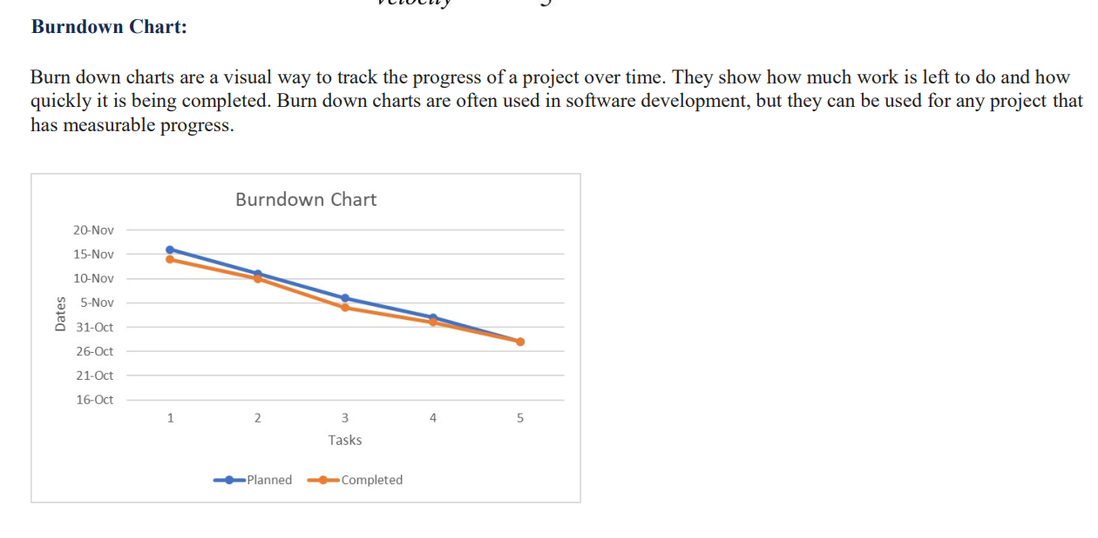

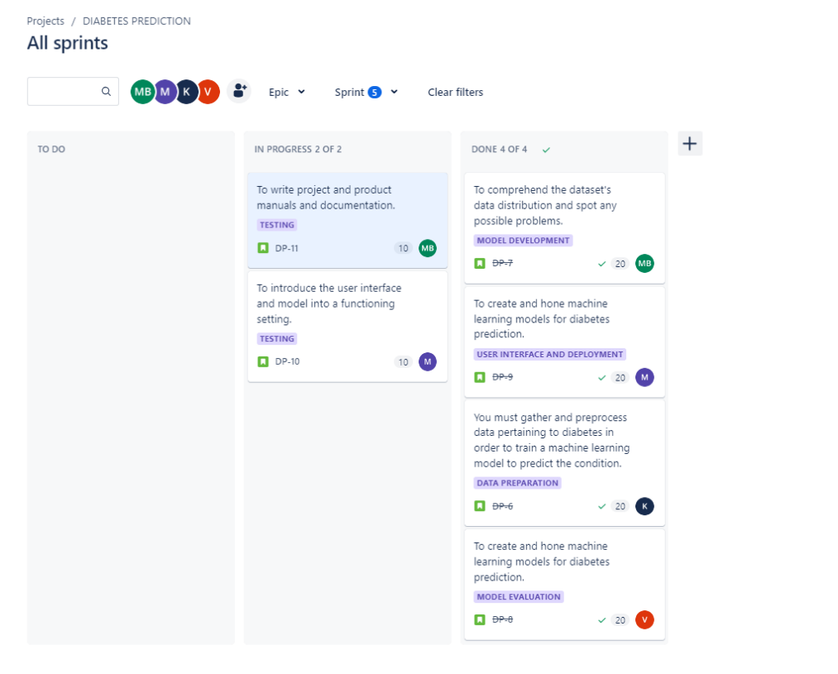

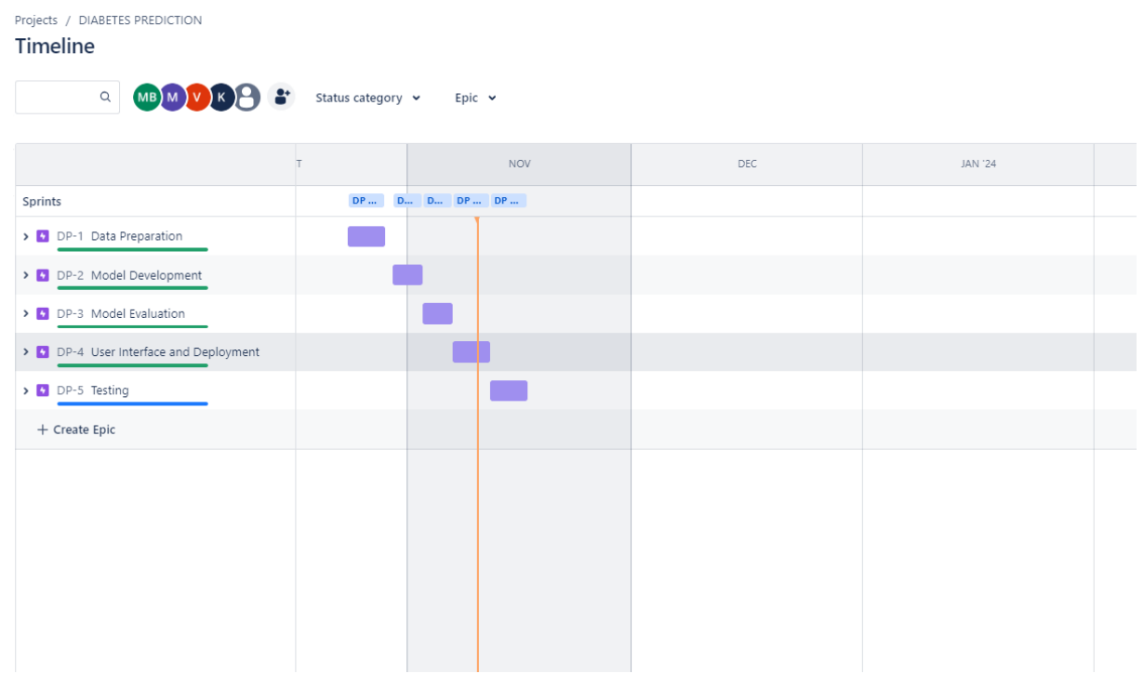

# 

# CODING

The characteristics (input variables) that our model will use to predict whether a person is likely to have diabetes must be defined in a machine learning project for diabetes prediction. These features ought to be carefully selected in accordance with their applicability and accessibility within the dataset. based on a few standard characteristics of the diabetes prediction project.

Age: An individual's age may have a major impact on their risk of diabetes.

Sex: Given that there have been differences between males and females in certain studies, gender may influence the risk of diabetes.

BMI: Based on height and weight, BMI is a measure of body fat and a reliable indicator of diabetes.

Blood Pressure: The values of the diastolic and systolic pressures can be significant characteristics.

Cholesterol Levels: A higher risk of diabetes may be linked to elevated levels of both total and low-density lipoprotein (LDL) cholesterol.

Physical Activity: Details regarding the person's workout routine or level of physical activity may be pertinent.

Smoking Status: It's important to include this as a feature because smoking can affect diabetes risk.

Alcohol Use: Alcohol use may be a feature of diabetes and can also influence the risk.

Any Medical Conditions: It may be important to consider the existence of additional medical conditions, such as polycystic ovarian syndrome (PCOS).

Stress Levels: If available, this information can be included. Persistent stress has been shown to impact diabetes risk.

# 

# PERFORMANCE MATRIX

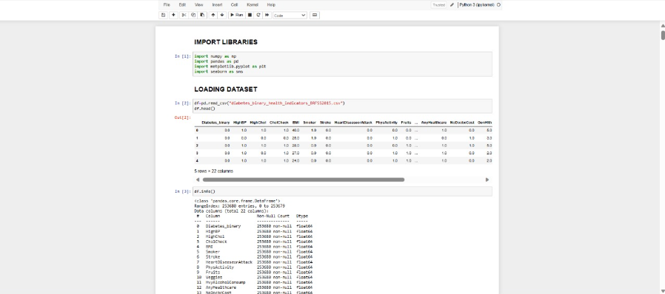

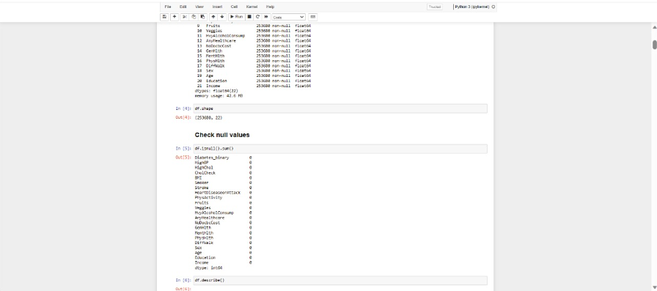

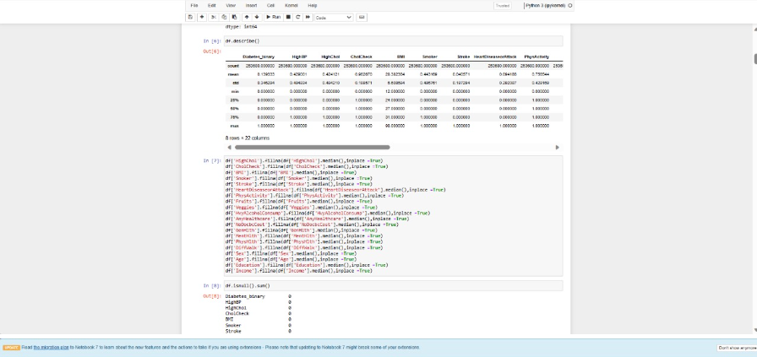

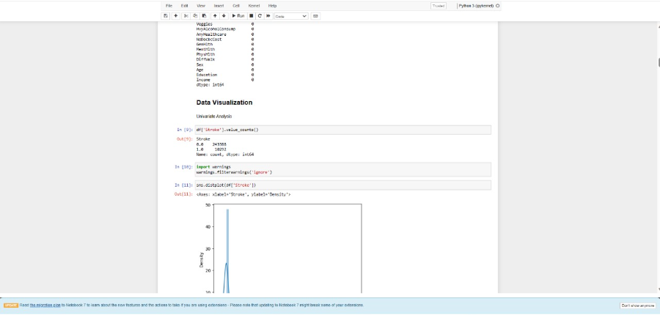

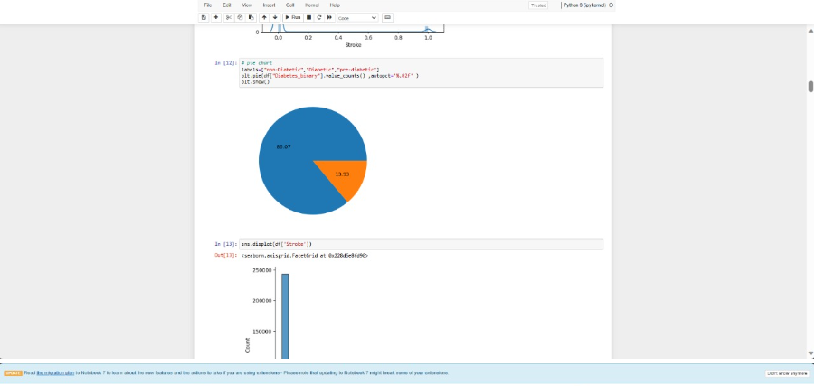

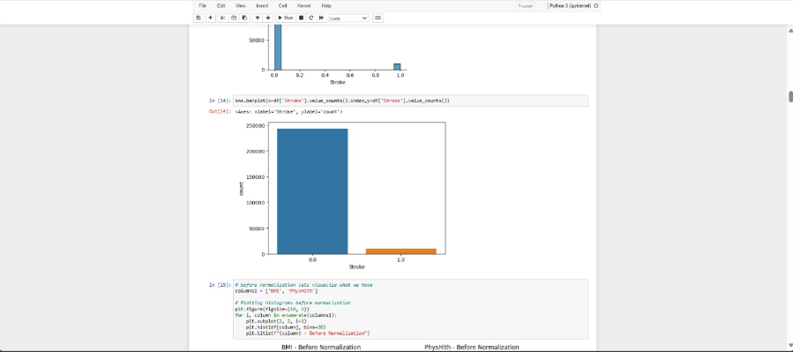

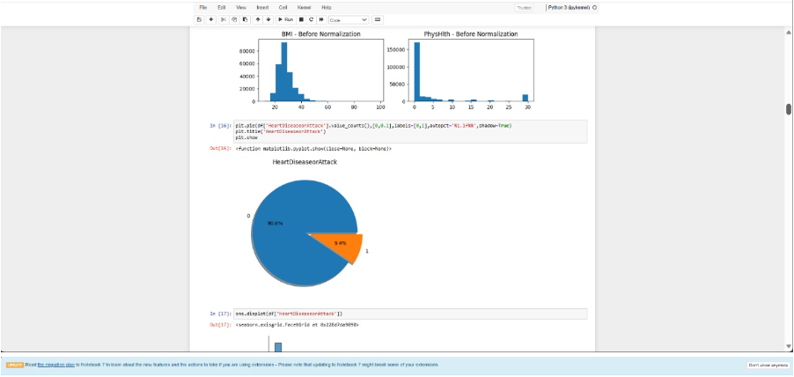

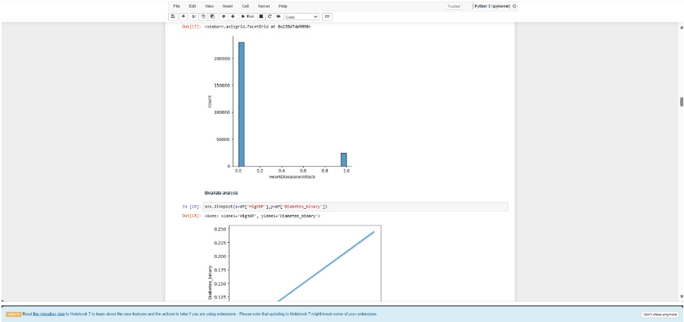

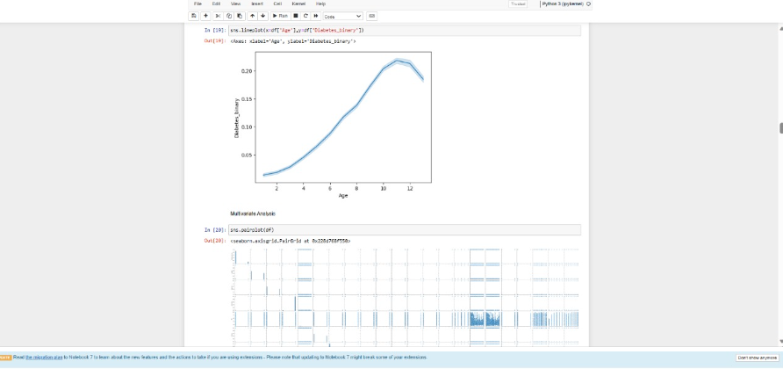

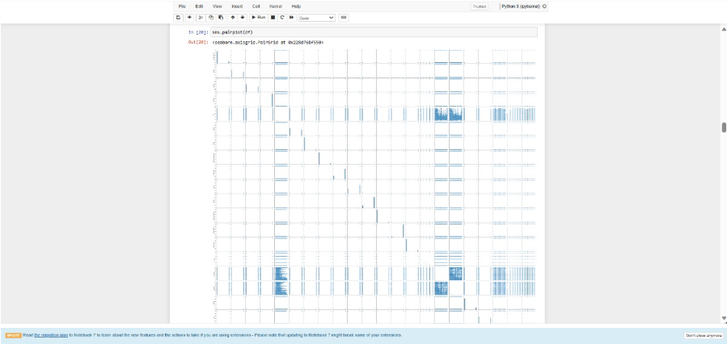

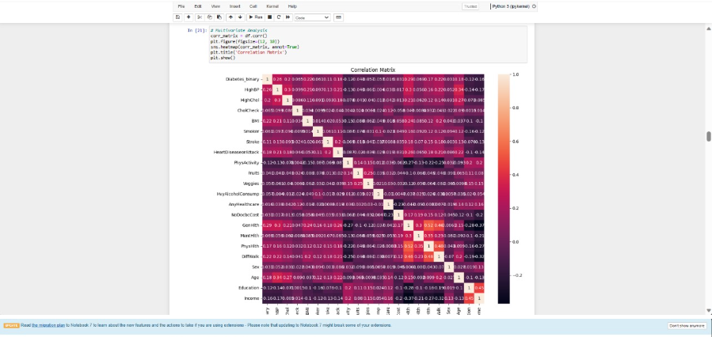

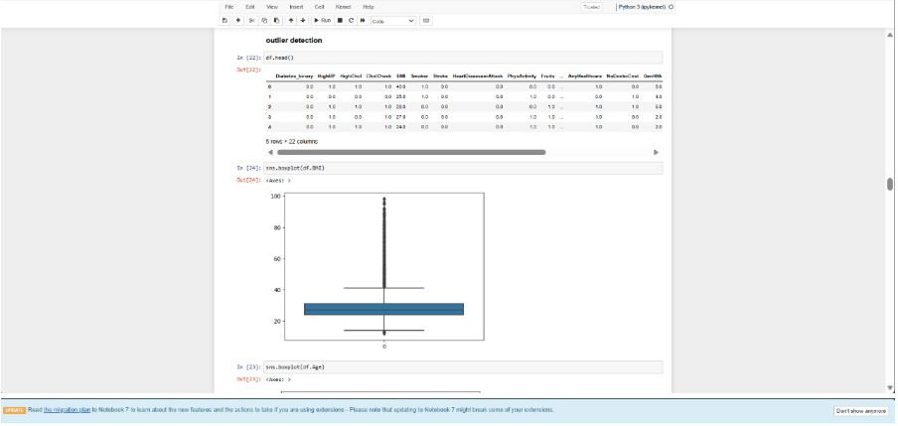

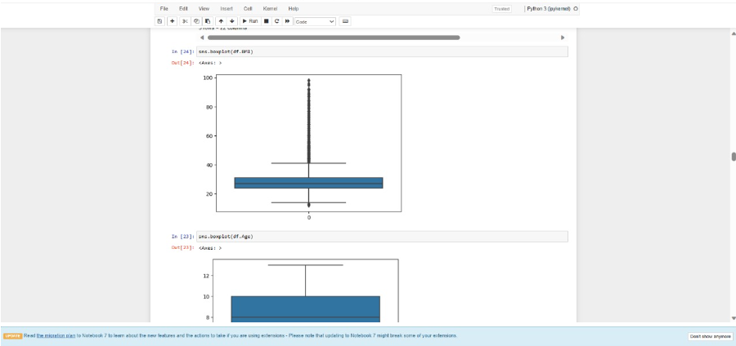

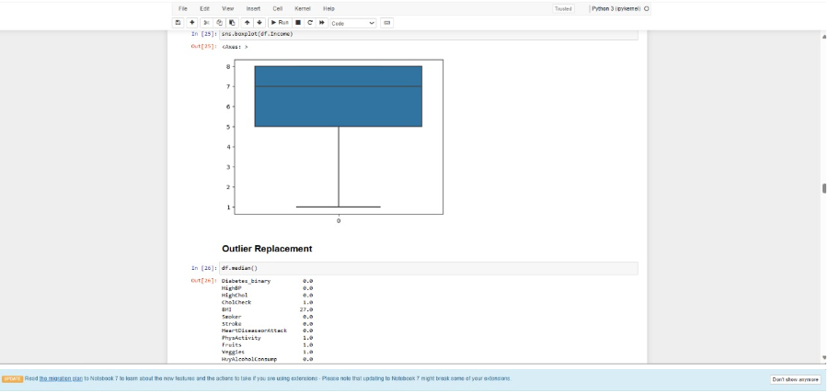

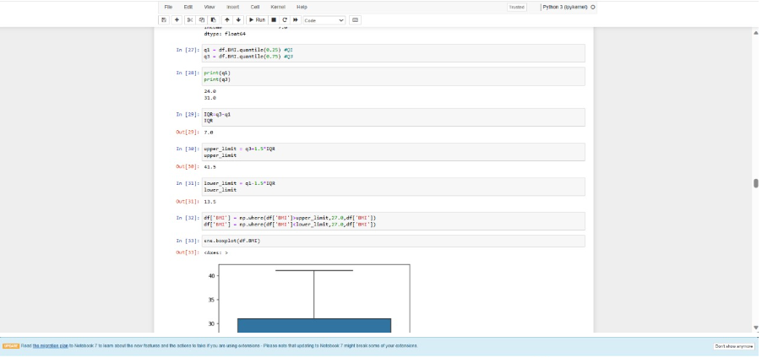

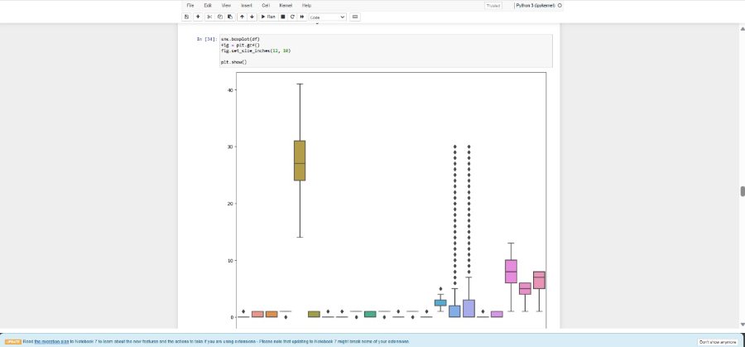

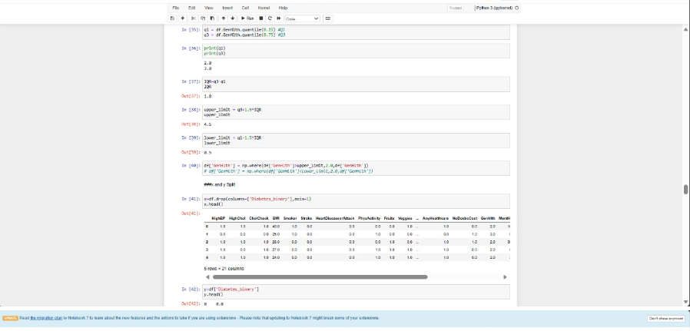

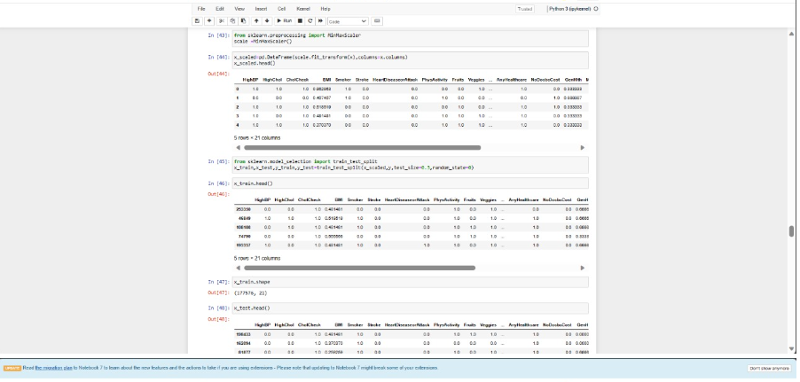

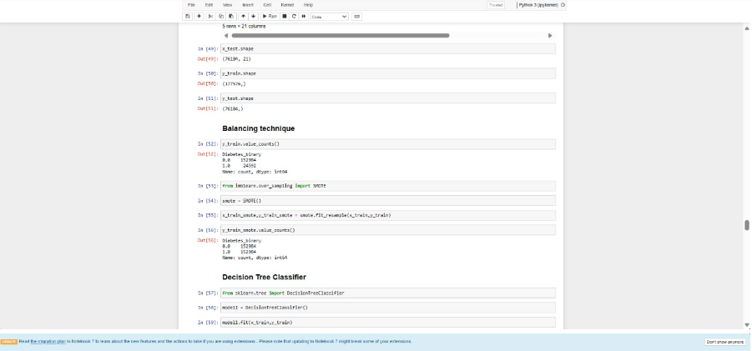

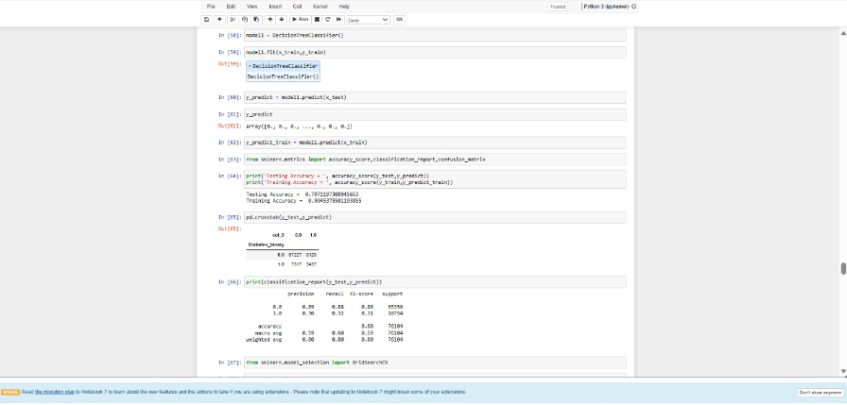

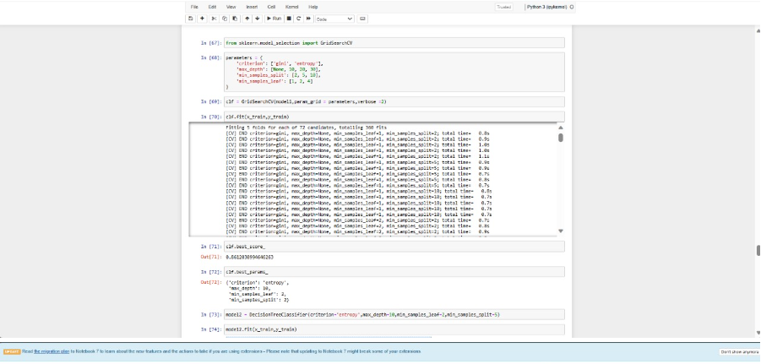

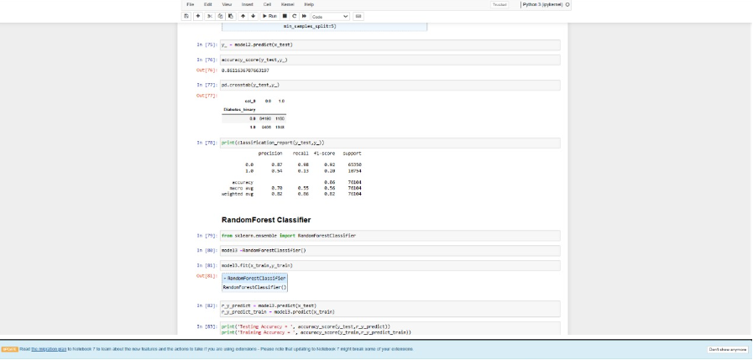

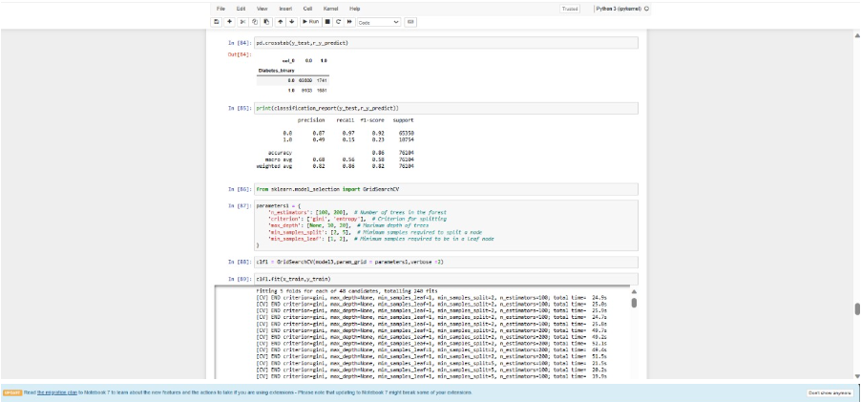

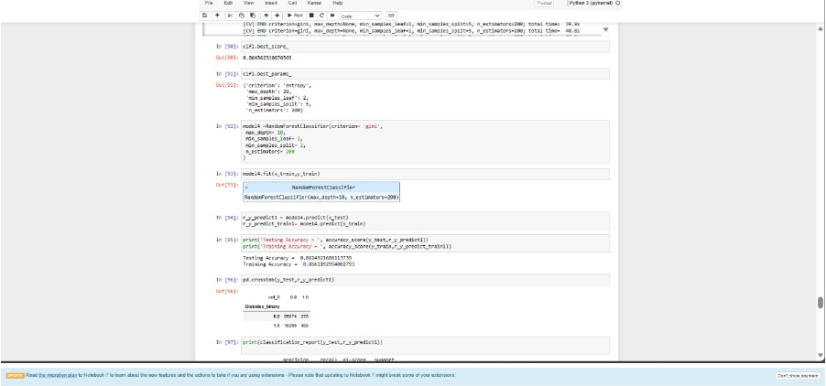

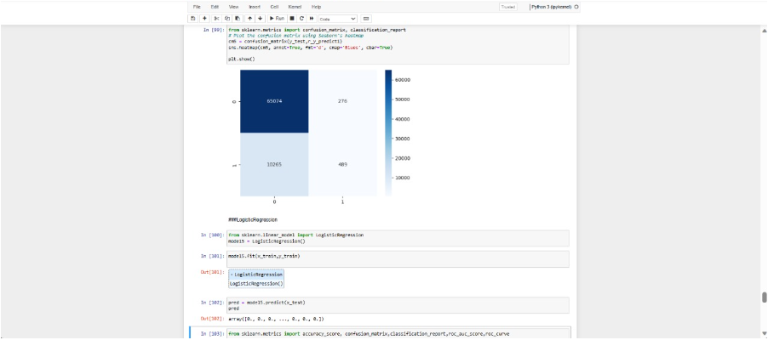

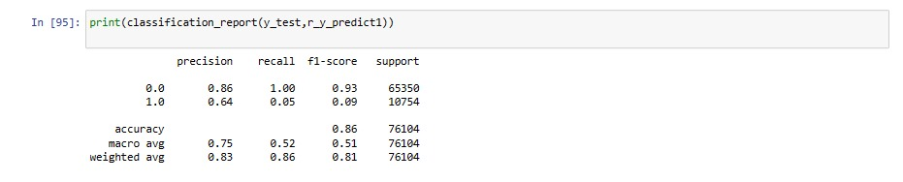

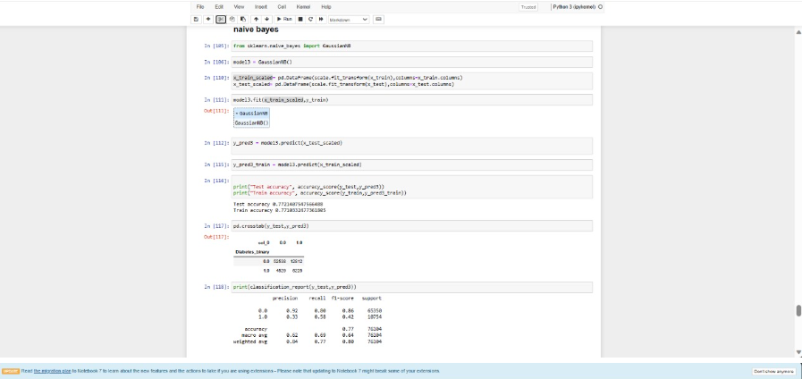

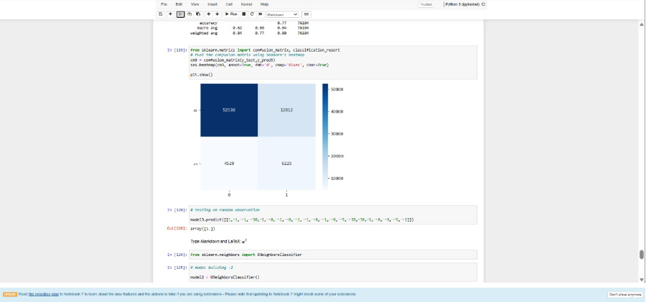

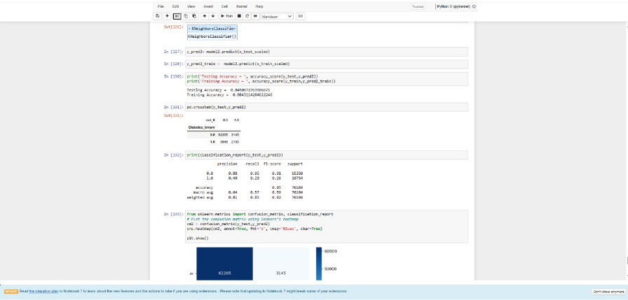

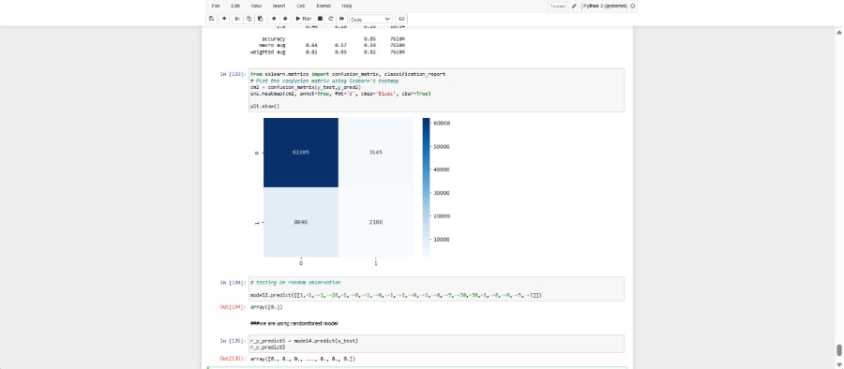

# 

# RESULTS

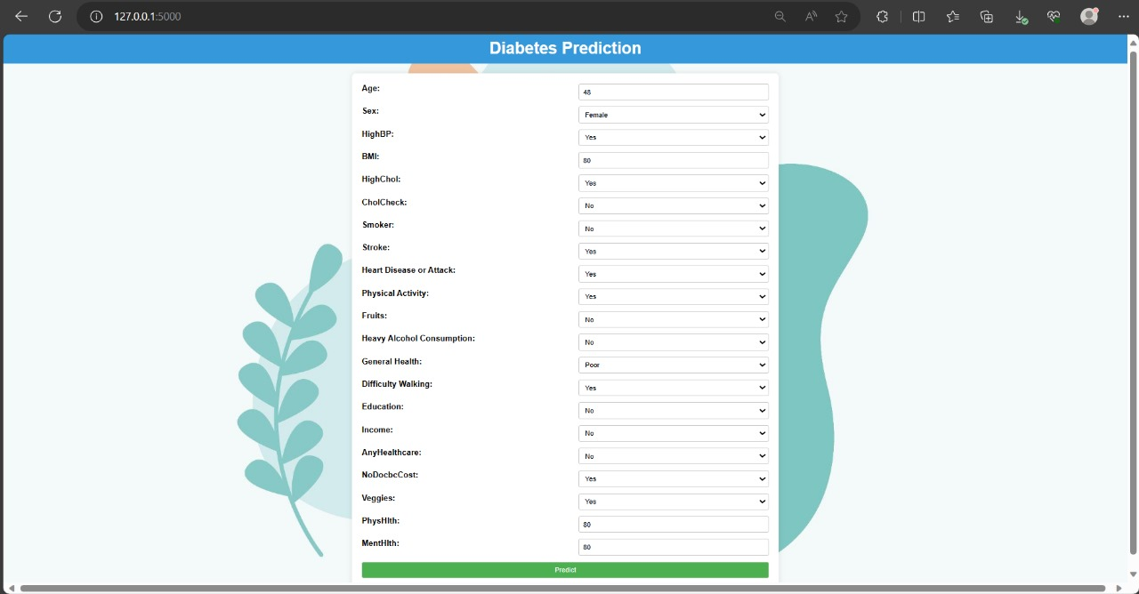

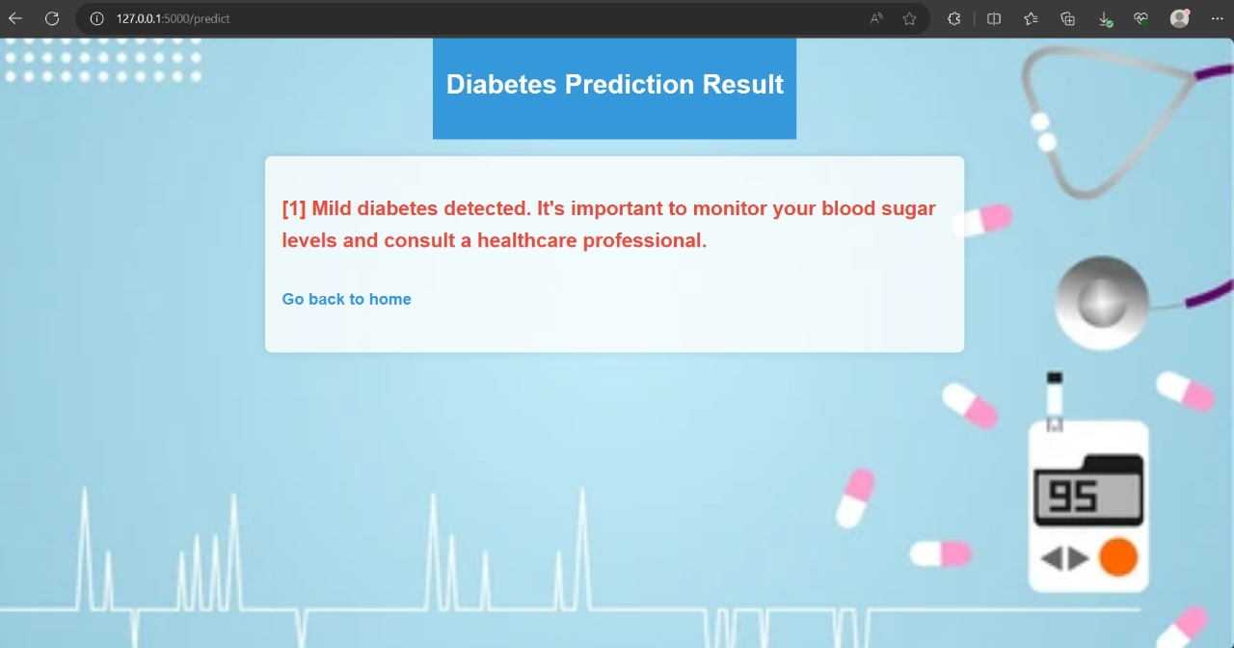

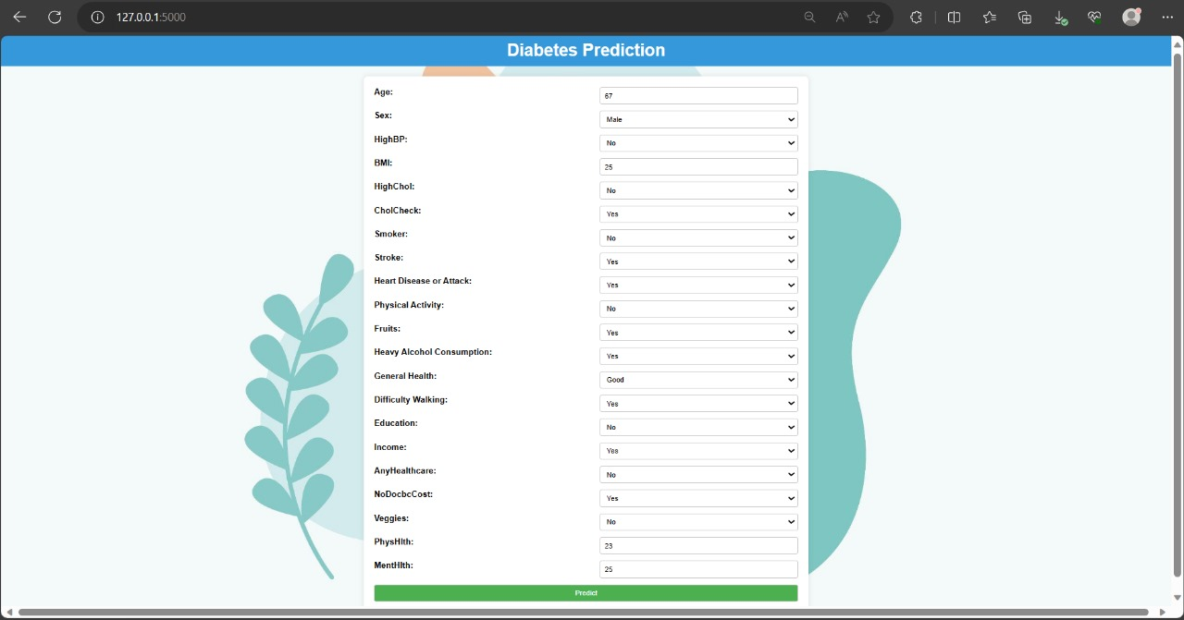

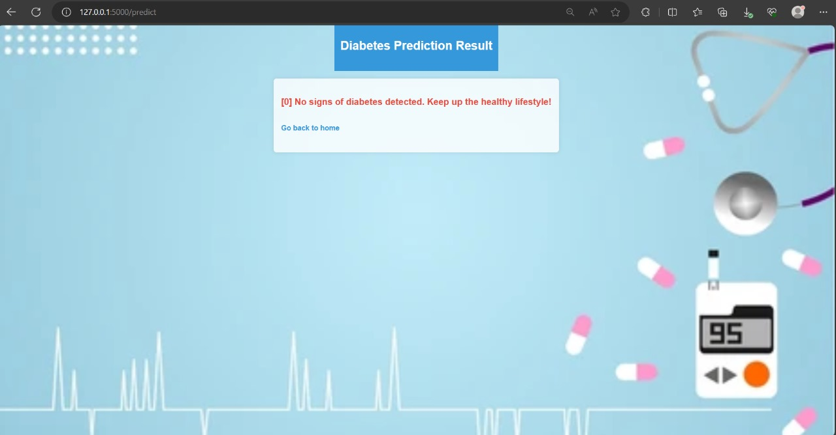

# 

# ADVANTAGES & DISADVANTAGES

Benefits

Early detection: Diabetes can be identified with the aid of machine learning algorithms, which can result in prompt treatment and improved results.

Accuracy: Machine learning algorithms have the capacity to evaluate vast volumes of data and generate precise forecasts. Treatment plans that are specifically tailored to each patient can be created with the aid of machine learning algorithms, taking into account their medical history as well as other variables.

Economical: By anticipating diabetes symptoms and averting complications, machine learning algorithms can lower healthcare expenses.

Negative aspects:

Data quality: To produce precise predictions, machine learning algorithms need high-quality data. Inaccurate forecasts can result from poor data quality.

Data privacy: Since machine learning algorithms need to access sensitive patient information, privacy issues may arise.

Bias: If the training data is not sufficiently diverse, machine learning algorithms may exhibit bias. For some patient groups, this may result in erroneous predictions.

# 

# CONCLUSION

To sum up, Diabetes Prediction is a big step in the direction of individualized treatment and preventive health. This cutting-edge app gives users the ability to take proactive control of their health journey by utilizing artificial intelligence. The machine learning model makes timely predictions by carefully examining various health parameters and lifestyle choices. This empowers users to take preventive action and make well-informed decisions. This predictive model's smooth integration into an intuitive web application improves accessibility and encourages a health-conscious culture. In this case, the nexus between technology and healthcare emphasizes how machine learning has the ability to revolutionize illness prediction and prevention.

The effective creation of this diabetes prediction model opens up new avenues for investigation and practical uses in targeted interventions and personalized medicine. The knowledge acquired from this project advances our comprehension of the fundamental causes and mechanisms of diabetes. The developed tool's accessibility and ease of use enable its possible implementation in actual healthcare environments, which will benefit patients as well as healthcare providers.

All things considered, the project makes a substantial contribution to the field of healthcare analytics and shows how machine learning can be used to improve diabetes early detection and management, which will ultimately improve patient care and quality of life.

# 

# FUTURE ASPECTS

# Accuracy: The accuracy of diabetes prediction can be increased by further refining machine learning algorithms. Increasing the number of data sources, utilizing more sophisticated algorithms, and enhancing data quality can all help achieve this.

# Treatment plans that are specifically tailored to each patient can be created using machine learning algorithms and take into account their medical history as well as other variables. Better results and increased patient satisfaction may result from this.

# Real-time monitoring: When patients exhibit symptoms of diabetes, machine learning algorithms can be used to monitor them in real-time and send out timely alerts. This may contribute to better patient outcomes and the avoidance of complications.

Integration with wearables: To track patients' health in real time, wearables like fitness trackers and smartwatches can be integrated with machine learning algorithms. This can help anticipate the onset of diabetes and offer insightful information about the health of the patients.

Complications prediction: Diabetes-related complications like kidney disease, nerve damage, and heart disease can be anticipated with the use of machine learning algorithms. This may contribute to better patient outcomes and the avoidance of complications.

Resolving privacy issues: Since machine learning algorithms need access to private patient information, privacy issues may arise. Subsequent investigations may concentrate on creating machine learning algorithms for diabetes prediction that are safe and respect privacy.